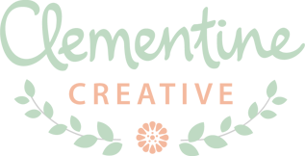
Carmia Cronjé
Phone 072 9656 755
E-mail carmia@clementinecreative.co.za
Web design.clementinecreative.co.za

STATIONERY DESIGN QUESTIONNAIRE
Please complete the questions below to the best of your abilities. It will give me a better idea of what you require and the scope of the project.
1. What stationery do you require?
E.g. Wedding invitation/birthday invitation, etc.
2. What size do you require? (if changes to the size need to be made later on, an additional fee may be a charged)
E.g. A5 size, 5x7 inch, etc.
3. Where do you intend on printing?
E.g. Home printer, online or print shop?
4. Are you going to be supplying the wording?

5. Do you require any photo retouching or manipulation?

6. Do you require a single or double sided design?

7. What look and feel do you want the design to have?
For example / fun / formal / elegant / feminine / corporate / casual / serious / other.
8. What colour palettes might you prefer?

9. How many options would you like to see? (optional)

10. What is your budget for this? (optional)

11. Please describe the design you have in mind and attach any images of designs you like.

--------------------------------------------------------------------------------------------------------------------------------------
Please send the completed form to carmia@clementinecreative.co.za
The stationery design process consists of sending options via email. When a preferred option is chosen it is then modified further until the final design is signed off.
Following your answers I will send you a proposal with what you can expect. If you have any questions please let me know!
Kind regards,
Carmia Cronjé

